

**22nd ANNUAL HUMAN FACTORS AND ERGONOMICS SYMPOSIUM**

**September 15, 2022**



Human Factors and Ergonomics Society, Puget Sound Chapter

|  |  |
| --- | --- |
| 7:15 | Webinar Open for Log In |
|  |  |
| 7:30 | Welcome – Niki Howard, PSHFES President |
|  |  |
| 7:45 | Human Factors & Ergonomics Society (HFES) President’s Address – Carolyn Sommerich |
|  |  |
| 8:00-8:55 | **Can Following Procedures Enhance Teamwork?**  **Dr. Deborah Boehm-Davis**  This presentation will provide an overview of a 5-year research program conducted in partnership with a regional air carrier. Our goal was to create procedures to address issues the airline was having (e.g., rejected take-offs), with the goal of using those procedures as a model for good crew resource management. The hope was that the procedures would generalize beyond the trained procedures. Did it work? Tune in to find out. |
|  |  |
| 9:00-9:30 | ***Nextg* Presentations**  **Zhenyu Zhang, UW:** Participatory Ergonomic Intervention at a Roofing Company: Preliminary Evaluation Results and Lessons Learned  **Kiana Kia, OSU:** The Effects of Interface Design on Biomechanical and Cognitive Load Measure During Augmented Reality Interactions**.** |
|  |  |
| 9:30-10:00 | Break |
|  |  |
| 10:00-10:55 | **Ergonomics in Labor-Intensive Agriculture: Research, Interventions, and Outreach**  **Dr. Fadi Fathallah**  This talk will give an overview of ergonomics research activities at UC Davis, which focus on addressing musculoskeletal disorders (MSDs) among farmworkers engaged in labor-intensive practices in the harvest and maintenance of a wide range of specialty crops. Potential interventions and outreach efforts to reduce MSDs in this population will also be discussed. |
|  |  |
| 11:00-11:15 | **Industry Case Study: A Participatory Ergonomics Approach to an Old LRT Maintenance Problem: A Case Study on Improving Track Grooving**  Shane Hudson, EWI Works |
|  |  |
| 11:15-11:30 | Sponsor Panel Discussion |
|  |  |
| 11:30-11:45 | HFE Professional of the Year Award |
|  |  |
| 11:45-12:15 | Break and Questions for Our Sponsor Panel |
|  |  |
| 12:15-1:10 | **Exploring the Contribution of Ergonomics and Human Factors to Sustainability and Addressing Climate Change**  **Dan Gottesman**  This presentation will explore the intersection of HFE and Sustainability with a special focus on environmental sustainability and climate change. The questions which we will seek to answer include: “Why is HFE a key territory in the advancement of sustainability?” and “How can ergonomics and human factors professionals accelerate the progress on the path to sustainability?”. Hint: “collaboration is key”. |
|  |  |
| 1:15-1:45 | Speaker Panel |
|  |  |
| 1:45-2:00 | Closing Remarks |

Speaker Biographies

**Deborah Boehm-Davis**

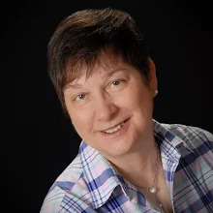**Can following procedures enhance teamwork?**

Deborah A. Boehm-Davis recently retired from Meta (Facebook Reality Labs) where she was a Research Manager. She also is University Professor Emeritus of Psychology and former Dean of the College of Humanities and Social Sciences at George Mason University. She received her graduate degrees from the University of California, Berkeley and her bachelor’s degree from Douglass College (Rutgers University). In addition to her work at George Mason University and Meta, she worked on applied cognitive research at General Electric, NASA Ames and Bell Laboratories. She also served as Senior Policy Advisor for Human Factors at the Food and Drug Administration’s Center for Devices and Radiological Health.

**Fadi Fatallah**

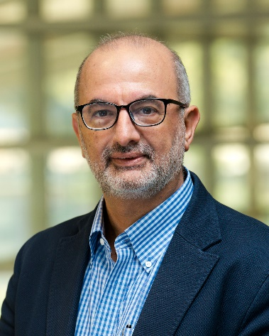**Ergonomics in Labor-Intensive Agriculture: Research, Interventions, and Outreach**

Fadi Fathallah is a Professor and Chair of the Department of Biological and Agricultural Engineering at the University of California, Davis (UC Davis). Professor Fathallah has over 30 years of experience conducting basic and applied research on ergonomics, biomechanics, and occupational health and safety related to workers in various occupational settings, with special emphasis on farmworkers in the past two decades. He has been an active member of HFES since he joined as a student member in 1987, and he is a Certified Professional Ergonomist (CPE).

**Dan Gottesman**

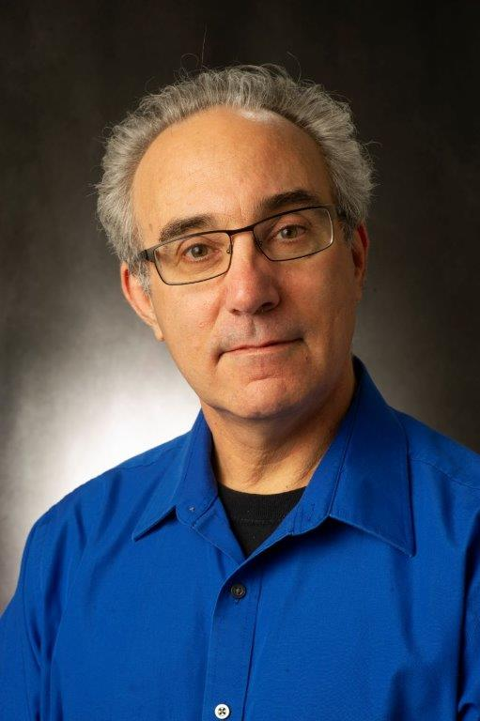**Exploring the Contribution of Ergonomics and Human Factors to Sustainability and Addressing Climate Change**

Dan Gottesman entered the field of ergonomics in 1987. Now in his 3rd act, Dan’s current focus is on the application of what we already know about ergonomics and human factors to the critical areas of Sustainability and Climate Change. Dan’s career has included research, consulting, and corporate roles covering a wide range of work, primarily in industrial environments. His work places have included: The Boeing Company, The Center for Ergonomics at the University of Michigan, The Low Back Pain Rehabilitation Engineering Center at the University of Vermont, and a few consulting firms. Throughout his career Dan has championed knowledge sharing initiatives that value everyone's ideas and contributions. Examples include the Ergo Cup competition at the Applied Ergonomics Conference for which Dan has volunteered many years and best practice sharing at The Boeing Company where Dan served as the leader of the Ergonomics Community of Practice.